First Application

Androidmanifestfile

<?xml version="1.0" encoding="utf-8"?>  
<manifest xmlns:android="http://schemas.android.com/apk/res/android"  
 xmlns:tools="http://schemas.android.com/tools">  
  
 <application  
 android:allowBackup="true"  
 android:dataExtractionRules="@xml/data_extraction_rules"  
 android:fullBackupContent="@xml/backup_rules"  
 android:icon="@mipmap/ic_launcher"  
 android:label="@string/app_name"  
 android:roundIcon="@mipmap/ic_launcher_round"  
 android:supportsRtl="true"  
 android:theme="@style/Theme.FirstApplication"  
 tools:targetApi="31">  
 <activity  
 android:name=".MainActivity"  
 android:exported="true">  
 <intent-filter>  
 <action android:name="android.intent.action.MAIN" />  
  
 <category android:name="android.intent.category.LAUNCHER" />  
 </intent-filter>  
 </activity>  
 </application>  
  
</manifest>

In this application we are using view binding:

First go to build.gradle.kts(Module :app)

Then write this

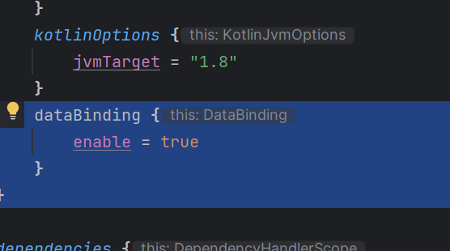

dataBinding **{** enable = true  
 **}  
}**

than go to color.xml add some color

like

<?xml version="1.0" encoding="utf-8"?>  
<resources>  
 <color name="black">#FF000000</color>  
 <color name="white">#FFFFFFFF</color>  
 <color name="screen_1">#E91E63</color>  
 <color name="screen_2">#248C29</color>  
</resources>

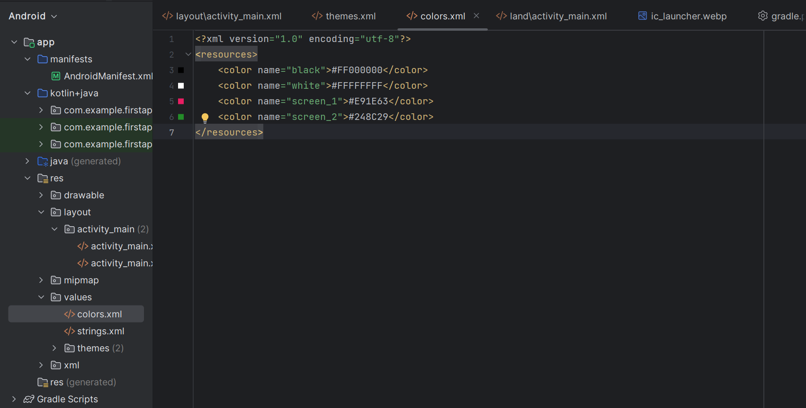

Then go to string xml and add

<resources>  
 <string name="app_name">First Application</string>  
 <string name="tx_portrait_mode">Portrait Mode</string>  
 <string name="tx_landscape_mode">Landscape Mode</string>  
 <string name="btn_increment">Increment</string>  
</resources>

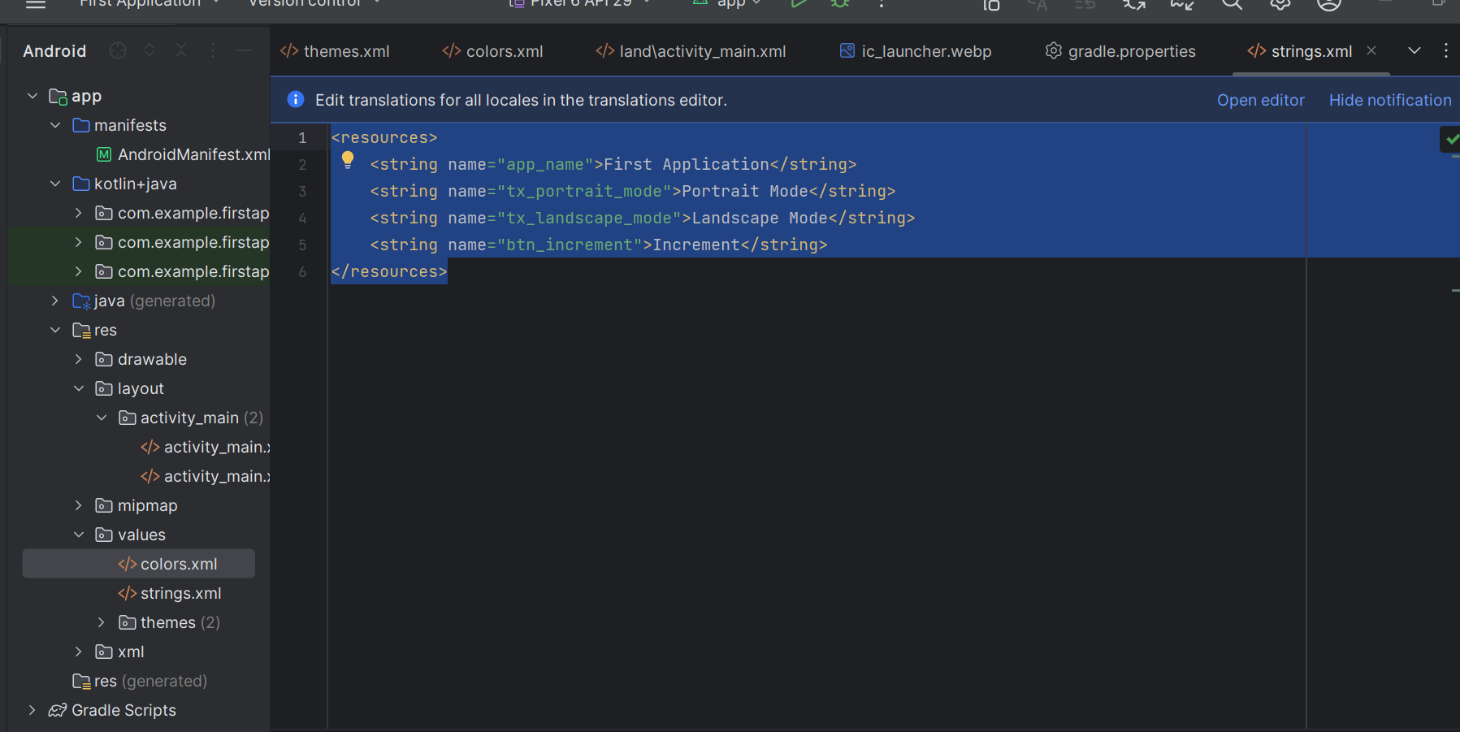

Then go to themes

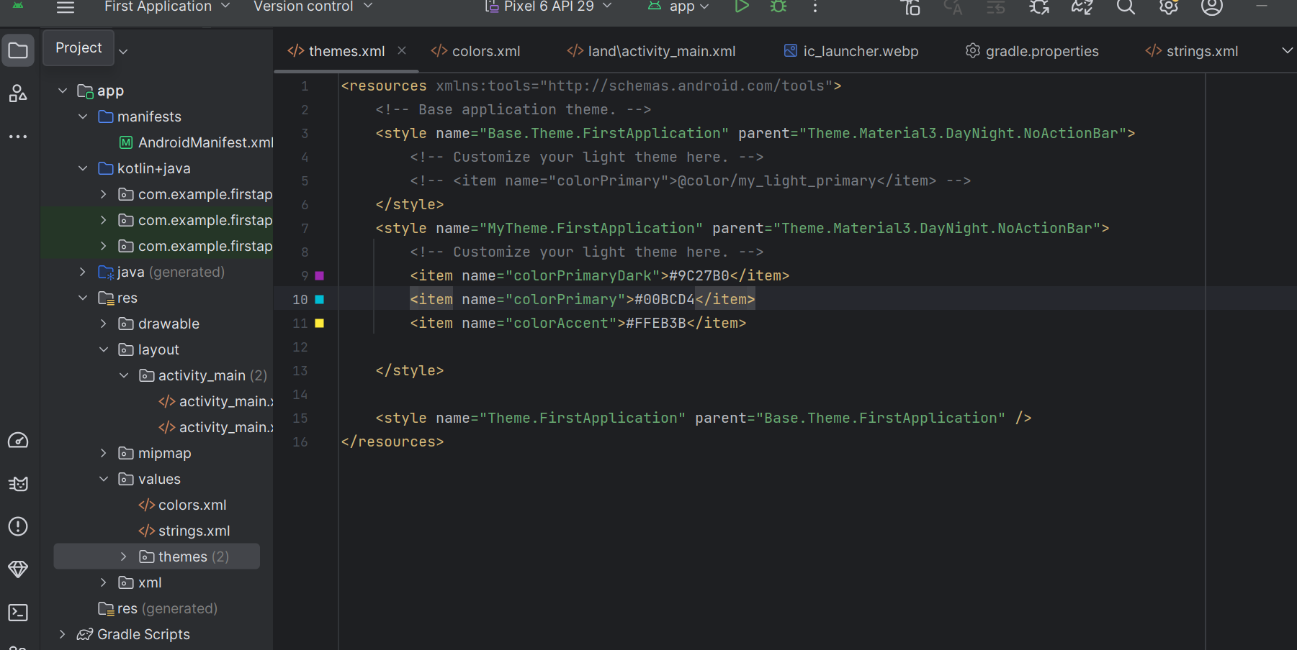

<resources xmlns:tools="http://schemas.android.com/tools">  
 <!-- Base application theme. -->  
 <style name="Base.Theme.FirstApplication" parent="Theme.Material3.DayNight.NoActionBar">  
 <!-- Customize your light theme here. -->  
 <!-- <item name="colorPrimary">@color/my_light_primary</item> -->  
 </style>  
 <style name="MyTheme.FirstApplication" parent="Theme.Material3.DayNight.NoActionBar">  
 <!-- Customize your light theme here. -->  
 <item name="colorPrimaryDark">#9C27B0</item>  
 <item name="colorPrimary">#00BCD4</item>  
 <item name="colorAccent">#FFEB3B</item>  
  
 </style>  
  
 <style name="Theme.FirstApplication" parent="Base.Theme.FirstApplication" />  
</resources>

Main Activity

package com.example.firstapplication  
  
import android.annotation.SuppressLint  
import androidx.appcompat.app.AppCompatActivity  
import android.os.Bundle  
import android.view.View  
import android.widget.Button  
import android.widget.TextView  
import androidx.databinding.DataBindingUtil  
import com.example.firstapplication.databinding.ActivityMainBinding  
  
class MainActivity : AppCompatActivity()/*,View.OnClickListener*/{  
 private lateinit var binding:ActivityMainBinding  
 private var counter =0  
 @SuppressLint("MissingInflatedId")  
 override fun onCreate(savedInstanceState: Bundle?) {  
 super.onCreate(savedInstanceState)  
 binding = DataBindingUtil.setContentView(this,R.layout.*activity_main*)  
 /*val counterTextView = findViewById<TextView>(R.id.counter_textview)  
 val counterBtn = findViewById<Button>(R.id.counter_btn)  
 counterBtn.setOnClickListener {  
 ++counter  
 counterTextView.setText("$counter")  
 }*/  
  
 /* binding.counterBtn.setOnClickListener {  
 ++counter  
 binding.counterTextview.setText("$counter")  
 }*/  
 /* binding.apply {  
 counterBtn.setOnClickListener{  
 ++counter  
 counterTextview.setText("$counter")  
 }  
 }*/  
 val isContainCounter = savedInstanceState?.containsKey("counter")?:false  
 if (isContainCounter){  
 counter = savedInstanceState?.getInt("counter")?:0  
 }  
 showCounter()  
 // binding.counterBtn.setOnClickListener(this@MainActivity)  
 binding.counterBtn.setOnClickListener(MyClickHandler(this))  
 }  
 fun showCounter(){  
 binding.counterTextview.setText("$counter")?:0  
 }  
 fun updateCounter(){  
 ++counter  
 }  
  
 /*override fun onClick(v: View?) {  
 ++counter  
 binding.counterTextview.setText("$counter")  
 }*/  
 override fun onSaveInstanceState(outState: Bundle) {  
 outState.putInt("counter",counter)  
 super.onSaveInstanceState(outState)  
 }  
  
 class MyClickHandler(var activity: MainActivity):View.OnClickListener{  
 override fun onClick(v: View?) {  
 /*if (v?.id == R.id.counter_btn){  
 activity.updateCounter()  
 activity.showCounter()  
 }*/  
 when(v?.*id*)  
 {  
 R.id.*counter_btn*-> {  
 activity.updateCounter()  
 activity.showCounter()  
 }  
  
  
 }  
  
  
 }  
  
 }  
}

activity_main

<?xml version="1.0" encoding="utf-8"?>  
<layout  
 xmlns:android="http://schemas.android.com/apk/res/android"  
 xmlns:app="http://schemas.android.com/apk/res-auto"  
 xmlns:tools="http://schemas.android.com/tools">  
  
 <androidx.constraintlayout.widget.ConstraintLayout  
 android:theme="@style/MyTheme.FirstApplication"  
 android:layout_width="match_parent"  
 android:layout_height="match_parent"  
 tools:context=".MainActivity">  
  
  
 <Button  
 android:id="@+id/counter_btn"  
 android:layout_width="wrap_content"  
 android:layout_height="wrap_content"  
 android:layout_marginTop="36dp"  
 android:text="@string/btn_increment"  
  
 app:layout_constraintEnd_toEndOf="parent"  
 app:layout_constraintStart_toStartOf="parent"  
 app:layout_constraintTop_toBottomOf="@+id/counter_textview" />  
  
 <TextView  
 android:id="@+id/counter_textview"  
 android:layout_width="wrap_content"  
 android:layout_height="wrap_content"  
 android:text="0"  
 android:textSize="24dp"  
 app:layout_constraintBottom_toBottomOf="parent"  
 app:layout_constraintEnd_toEndOf="parent"  
 app:layout_constraintStart_toStartOf="parent"  
 app:layout_constraintTop_toTopOf="parent" />  
  
 <TextView  
 android:id="@+id/textView3"  
 android:layout_width="wrap_content"  
 android:layout_height="wrap_content"  
 android:layout_marginStart="104dp"  
 android:layout_marginBottom="48dp"  
 android:text="@string/tx_portrait_mode"  
 android:textColor="@color/screen_1"  
 android:textSize="36dp"  
 app:layout_constraintBottom_toTopOf="@+id/counter_textview"  
 app:layout_constraintStart_toStartOf="parent" />  
  
 </androidx.constraintlayout.widget.ConstraintLayout>  
</layout>

Output

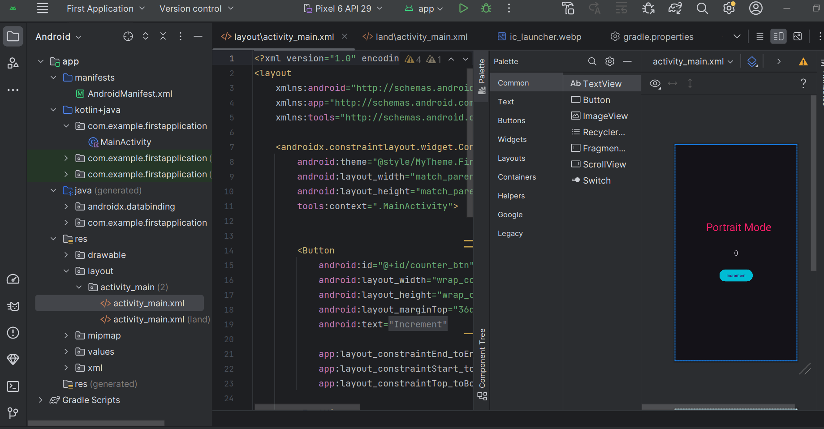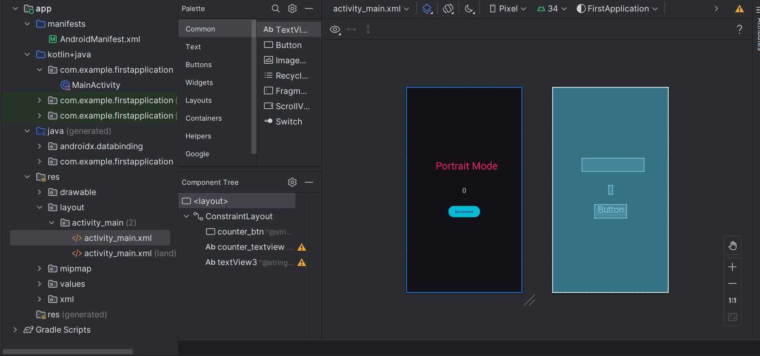

Second page Activity land

<?xml version="1.0" encoding="utf-8"?>  
<layout  
 xmlns:android="http://schemas.android.com/apk/res/android"  
 xmlns:app="http://schemas.android.com/apk/res-auto"  
 xmlns:tools="http://schemas.android.com/tools">  
  
 <androidx.constraintlayout.widget.ConstraintLayout  
 android:layout_width="match_parent"  
 android:layout_height="match_parent"  
 tools:context=".MainActivity">  
  
  
 <Button  
 android:id="@+id/counter_btn"  
 android:layout_width="wrap_content"  
 android:layout_height="wrap_content"  
 android:layout_marginTop="36dp"  
 android:text="@string/btn_increment"  
 app:layout_constraintEnd_toEndOf="parent"  
 app:layout_constraintStart_toStartOf="parent"  
 app:layout_constraintTop_toBottomOf="@+id/counter_textview" />  
  
 <TextView  
 android:id="@+id/counter_textview"  
 android:layout_width="wrap_content"  
 android:layout_height="wrap_content"  
 android:text="0"  
 android:textSize="24dp"  
 app:layout_constraintBottom_toBottomOf="parent"  
 app:layout_constraintEnd_toEndOf="parent"  
 app:layout_constraintStart_toStartOf="parent"  
 app:layout_constraintTop_toTopOf="parent" />  
  
 <TextView  
 android:id="@+id/textView3"  
 android:layout_width="wrap_content"  
 android:layout_height="wrap_content"  
 android:layout_marginStart="268dp"  
 android:layout_marginBottom="60dp"  
 android:text="@string/tx_landscape_mode"  
 android:textSize="36dp"  
 android:textColor="@color/screen_2"  
 app:layout_constraintBottom_toTopOf="@+id/counter_textview"  
 app:layout_constraintStart_toStartOf="parent" />  
  
 </androidx.constraintlayout.widget.ConstraintLayout>  
</layout>

Output

